The Food Standards Agency have an on-line course available free to the public which the Environmental Health, Development & Regulatory Services of London Borough of Barnet would recommend you arrange for your food handlers to complete.

Online food safety training | Food Standards Agency - https://www.food.gov.uk/business-guidance/online-food-safety-training

Please note that you may need to register as a Food business – please see https://www.food.gov.uk/business-guidance/how-to-register-a-food-business
This allergy and intolerance sign can be displayed to tell customers/participants how they can find allergy information, or create your own.
Attached is an allergen chart that you could use to record the allergens in your menu items and an allergen intolerance sign.

Dishes and their allergen content
(Note – Please state the name of the cereal(s) containing gluten* and/or the name of the nut(s)†)

Dishes | 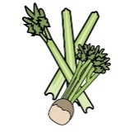 |  |  |  |  | 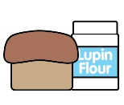 |  |  | 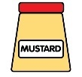 |  |  | 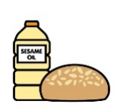
 | Celery | Cereals containing gluten* | Crustaceans | Eggs | Fish | Lupin | Milk | Mollusc | Mustard | Nuts† | Peanuts | Sesame seeds | Soya | Sulphur Dioxide
Tuna Salad [example] | ✓ |  |  | ✓ | ✓ |  | ✓ |  | ✓

Review date: |  | Reviewed by: |  |  | 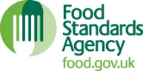 |  | You can find this template, including more information at www.food.gov.uk/allergy-guidance

